**University POLITEHNICA of Bucharest**

**Faculty of Electronics, Telecommunications and Information Technology**

**Project Title**

**Smart Traffic Control and Congestion Tracker System**

**Table of Contents**

Title Page no**.**

Table of content ………………………………………………………………………… **2**

Abstract ………………………………………………………………………………… **4**

Undertaking …………………………………………………...………….…..………… **5**

List of Figures ………………………………………………………………………….. **6**

List of Acronyms …………………….…………………………………….………….... **7**

1. **Introduction……………………………………..……………….……..……… 8**

1.1. Problem Statement …………………………………………….….……………….. **8**

1.2. Introduction of IoT…………………………………………….….……………....... **8**

1.3. Smart Traffic Control System………………………………….……………...….... **8**

1.4. Congestion Tracker System…………………………………….…..……………… **9**

1.5. Purpose of Project……………………………………………….………..………... **9**

1. **Literature Review………………………………………….………………..... 10**

2.1 Analysis …………………………………………….……………………...…….... **10**

2.2 Existing Products in Market…………………………………….………….…….... **10**

2.3 Objectives ………………………………………………....…………....….…….... **14**

2.4 Why our Project is better………………………………………….……………….. **11**

2.5. Traffic Calculation Method …………………………………….……..………….. **11**

1. **Project Introduction and Motivation……………………….……………….. 12**

3.1 Block diagram of System ………………………………………….………………. **12**

3.2 Components used in Hardware …………………………………….……….…….... **12**

3.2.1 Microcontroller Raspberry Pi …………….……………………….…….…….... **13**

3.2.2 Pi Camera ……………………………..……………….………….……….….... **13**

3.2.3 Servo motor …………………………………………………………...….…….... **14**

3.2.4 LED …………………………………………….………………………...…….... **15**

3.2.5 AC DC circuit converter power module………………...…..…………...…….... **16**

3.3 Project Diagram ……………………………………………………….….…..….... **16**

1. **Advantages and Disadvantages ……………………………....…………........ 18**

4.1 Advantages …………………………………...………………….……...………..... **18**

4.2 Disadvantages ……………………………………………………………..………. **18**

1. **Investigation …………………………………………....…………….....……. 19**

5.1 Investigation ……………………………………………………………...…..…… **19**

5.2 Working ……………………………………………………….………….…..….... **21**

1. **Conclusion …………………………………………....…………………...….. 23**

6.1 Impact on Society ………………………………………………………………..... **23**

6.2 Impact on Environment ………………………………………………………….....**23**

6.3 Future Work ………………………………………………………………...……... **24**

Acknowledgment ………………………………………………………………...……. **25**

Conflict of interest ………………………………………………………………...……**26**

Bibliography ………………………………………………………………………....... **27**

ANNEXURE ………………………………………………………………….………. **28**

Software code of …………………………………………………...………………….. **28**

**Abstract**

Traffic Signal Management is one of the crucial issues in the current era.The world is facing a lot of problems,urban mobility is one of the major problems.All traffic signals duration is most of the time 60 seconds but it is not fixed. Mosty, traffic on the roadside is less or dense depending upon the busy schedule, the traffic signals will be open for the same time in all situations.To encounter this problem, we introduced a system called *Smart Traffic Signal and Congestion Tracker System* which is an application of IoT (Internet of Things) that will resolve this problem. The main objective of our project is to save the time of each individual who is on the road going to their respective target destination.The Traffic signal’s timing interval will depend on the number of vehicles on each particular side. Our System contains the database in which it clicks the images of all the roadsides. The waiting time will be reduced if we make our system more efficient and effective, when traffic is congested then the timing interval will be more and vice versa. It will also reduce the cases of accidents on the roads due to traffic jams.

**Undertaking**

We certify that research work titled “*Smart Traffic Control and Congestion Tracker System”* is our work. The work has not been presented elsewhere for assessment. Where material has been used from other sources it has been properly acknowledged/ referred. We hereby declare that this project neither as a whole nor as a part thereof has been copied out from any source.

Signature:_________________

Name:____________________

**List of Figures**

Fig. 3.1. Block diagram ………………………………………………………………………..12

Fig 3.2. Raspberry pi 3 Board …………………………………………………..……………..13

Fig. 3.3 Pi camera ……..…………………………………………………….………………..14

Fig. 3.4. Stepper motor ……...………………………………………………..………………..15

Fig 3.5. LED lights ……..…………………………………………………….………………..16

Fig 3.6. AC DC circuit converter power module ..…………………………...………………..16

Fig 3.7. Complete project ……………………………………………….……………………..17

Fig 5.1. Data sended to the fire base ………………………………………..………..………..20

Fig 5.2.

Fig 5.3.

Fig 5.4. Traffic congestion report of Tramri Chowk Islamabad, Pakistan on E-gadget ………. 22

Fig 5.5. Smart Device Installed Junctions View in Mobile App …………………………..…..23

Fig 5.6.

**List of Acronyms**

**IoT:** Internet of Things

**RFID:** Radio-frequency identification

**GSM:** Global system for mobile communication

**ITS:** Intelligent Transportation Systems

**LED:** Light emitting diodes

**PWM:** Pulse width modulation

**CSI:** Camera serial interface

**AWT:** Average waiting time

**Chapter 1**

**Introduction**

* 1. **Problem Statement**

To manage the traffic smartly and efficiently is one of the major issues in the current era. Traffic signal’s timing interval is the same due to which dense and normal traffic side get the same time to move. We faced a lot of problems due to the huge traffic on roads especially during the morning and evening time when people persist from their respective organizations. Due to which traffic gets denser than usual causing different traffic issues.. Students who go to their institutes, workers who go to their offices and patients who go to the hospitals are stuck in the traffic and do not be able to reach on time to their respective location and face a lot of problems. Although, time is a weapon that must be utilized properly. Due to traffic issues, we waste a lot of our time. To resolve this problem, we have an effective and efficient solution.

* 1. **Introduction to IoT**

IoT (Internet of Things) is a network of physical objects containing embedded electronics which are connected to the internet through network devices. Electronic objects are inter connected with each other to collect and exchange information. Due to the advancement in technology, the components used in it are mentioned below:

* Low Power Embedded System
* Networking Connection
* Security Focus
* Smart System

**1.3 Smart Traffic Control System**

Everyday we are facing a lot of traffic issues. The first main objective is to reduce the waiting time of the people on the roadside. Therefore, we wanted to make the traffic system smarter and efficient. In the traffic control system, all sides of the road will be under observation and the roadside where the traffic is dense, the traffic will be open for more time whereas the roadside where traffic is less, the traffic signal will be open for a shorter time. By using this technique, the traffic will be more efficient and smoother. [1]

**1.3 Congestion Tracker System**

Congestion in traffic is a serious issue. In existing systems signal timings are fixed and they are independent of traffic density. Large red light delays lead to traffic congestion. In this paper, an IoT based traffic control system is implemented in which signal timings are updated based on the vehicle counting. This system consists of a WI-FI transceiver module that transmits the vehicle count of the current system to the next traffic signal. Based on the traffic density of the previous signal it controls the signals of the next signal. It will update each person about the congestion on particular roadside.The system is based on raspberry-pi and Arduino. Image processing of traffic video is done in MATLAB with simulink support. The whole vehicle counting is performed by raspberry pi. [2]

**1.4. Purpose of Project**

Main purpose of our project is to reduce the waiting time of the people on the road and to update the people about the congestion on the road. Our project helps each individual to reach their destination on time. Each person will be able to know about the congestion on the road, the person will adopt the best route to reach their organization.

**Chapter 2**

**Literature Review**

The world we are living in today is heavily suffering from traffic controlling issues. Many work has been done in the *Traffic Management System.* Smart Traffic management System using radio-frequency identification (RFID) which will eliminate the drawbacks of the existing system such as high implementation cost, dependency on the environmental conditions, etc. The proposed system aims at effective management of traffic congestion. It is also more cost effective than the existing system. Furthermore, the study presents the problems in metropolitan areas all over the world caused by congestions and the related sources. Congestions developed to a problem, which affects economies worldwide. Particularly metropolitan areas are worst hit under these conditions. Congestions have a negative impact on the financial situation of a country, on the environment and hence the overall quality of life. The proposed system can be enhanced by using any other powerful communication network other than global system for mobile communication (GSM). [3]

Intelligent Transportation Systems (ITS) is a global trend, attracting worldwide interest from transportation professionals, automotive industry, and political decision makers. ITS is related to advanced communication, information, and electronics technology to solve transportation problems such as traffic congestion, safety, transport efficiency and environmental conservation, characterized as:

* Automated Data Collection: It needs extensive and precise strategic planning through hardware and competent software. Automatic vehicle identification, GPS based vehicle locator, cameras, sensors etc. are some of the hardware used for data collection. With this large amount of data the analysis can be done like traffic count, surveillance, travel speed, time, location, delay etc.
* Data Transmission: It is a key aspect of rapid and real-time information communication in ITS implementation. Information can be communicated by a traffic-related announcement to the traveler through SMS, internet, on-board units of vehicles etc.
* Data Analysis: It contains adaptive logical analysis, error rectification, data cleaning, and data syntheses. The processed data analyzed further to forecast traffic scenarios. Real-time information like travel time, delay, accidents on roads, change in route, work zone, diversions etc. is the gain after data analysis.

**2.1. Analysis**

In the start we need following data

* Traffic on each side of the road
* Counting and send information to cloud network
* Updating the data on mobile app

**2.2. Existing Products in Market**

There are two types of traffic management and congestion control systems in the society nowadays; first one is the simple traffic light system that is installed on any of the road junctions in the country and continuously one and off after some time of all the sides. In this system counting of vehicle or traffic congestion or any other advanced options are not installed or in operated condition. Secondly the system is installed in which there are the timers in it everyone on the road junctions would stop on the road till the signal becomes green, same like previous system no advanced option in it like tracking, counting of vehicles or any other cloud sending data.

**2.3. Objectives**

* To attain maximum efficiency from the existing road network while minimising adverse impacts of traffic.
* To provide innovative services related to different modes of transport.
* To provide a comfortable environment.
* To provide the congestion information.

**2.4. Modern tool Usage**

Before commencing the hardware work, simulation for the basic circuits of the project for smart traffic control and congestion tracker has been ran as shown in fig 2.1

**2.5. Traffic Calculation Method**

To calculate the traffic, we must know the delay of the camera rotation and time of collection of traffic. Measurement of this traffic counting may be done by measuring the traffic parameters of the system. We are using only the resistive load for the sake of simplicity.

**Chapter 3**

**Project Introduction & Motivation**

**3.1. Block Diagram of System**

System consists of a microcontroller Raspberry pi which acts as a main processing unit of our project, Pi Camera for image processing, Servo Motor, light emitting diodes (LEDs) which acts as a signal and mobile application. The block Diagram of our Project *Traffic Signal Control and Congestion Tracker System* is mentioned below:

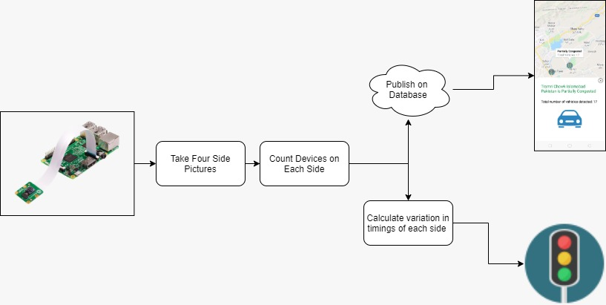

Fig. 3.1. Block diagram

**3.2 Components used in Hardware**

1. Raspberry pi (Microcontroller)
2. Pi Camera
3. Stepper Motor
4. LEDs
5. AC DC circuit converter power module

Components Specifications are mentioned below:

**3.2.1. Microcontroller Raspberry Pi**

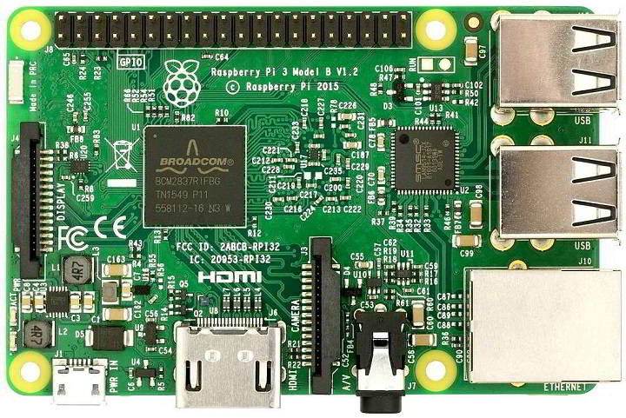

Fig 3.2. Raspberry pi 3 Board

Raspberry Pi is a small single board computer. By connecting peripherals like Keyboard, mouse, display to the Raspberry Pi, it will act as a mini personal computer. It is used for real time Image/Video Processing, IoT based applications and Robotics applications. It is slower than a laptop or desktop but is still a computer which can provide all the expected features or abilities, at a low power consumption. [4]

**3.2.2 Pi Camera**

Pi Camera module is a camera which can be used to take pictures and high definition video.

Raspberry Pi Board has CSI (Camera Serial Interface) interface to which we can attach PiCamera modules directly. It can attach to the Raspberry Pi’s CSI port using a 15-pin ribbon cable. [5]

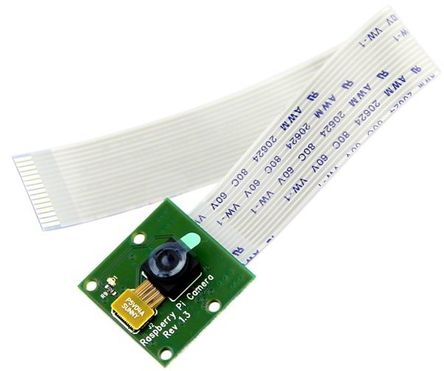

Fig. 3.3 Pi camera

# **Features of Pi Camera:**

* Resolution – 5 MP
* HD Video recording
* It Can capture wide, still (motionless) images of resolution 2592x1944 pixels
* CSI Interface enabled

**3.2.3 Stepper motor**

Stepper motors are DC motors that move in discrete steps. They have multiple coils that are organized in groups called "phases". By energizing each phase in sequence, the motor will rotate, one step at a time. With a computer controlled stepping you can achieve very precise positioning and/or speed control.

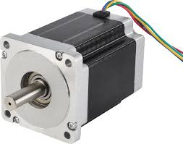

Fig. 3.4. Stepper motor

**Features of stepper motor:**

* Small step angle
* High positioning accuracy
* High torque to inertia ratio
* Stepping rate and accuracy

**3.2.4 LED**

A light-emitting diode (LED) is a semiconductor device that emits visible light when an electric current passes through it. The light is not particularly bright, but in most LEDs it is monochromatic, occurring at a single wavelength. The major uses of LED (Light Emitting Diodes) is to illuminate objects and even places. Its application is everywhere due to its compact size, low consumption of energy, extended lifetime and flexibility in terms of use in various applications.

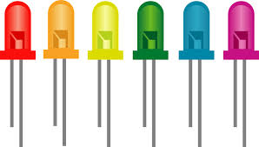

Fig 3.5. LED lights

**3.2.5. AC DC Circuit Converter Power Module**

AC-DC converters are electrical circuits that transform alternating current (AC) input into direct current (DC) output. AC to DC converters use rectifiers to turn AC input into DC output, regulators to adjust the voltage level, and reservoir capacitors to smooth the pulsating DC.Circuits often require an integrated AC power source as the optimum strategy to reduce size, cost or due to application specific needs.

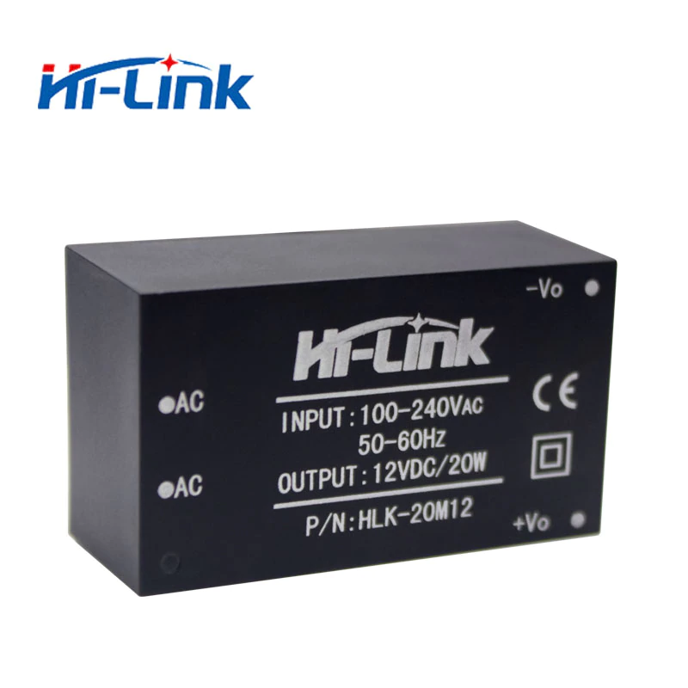

Fig 3.6. AC DC circuit converter power module

**Features of AC DC circuit converter power module:**

* Rated input voltage 100-240 VAc
* Input voltage range 90-264 VAc
* Maximum input current ≤0.2 A
* Input current surge ; ≤10 A
* maximum input voltage ≤270 VAc

**3.3. Project Diagram**

The complete project is shown in Fig 3.7.

**Chapter 4**

**Advantages and Disadvantages**

**4.1 Advantages**

* It reduces the time spent on roads because of road congestion and improves efficiency.
* Reducing the hazard of accidents and roads became much safer.
* Provide the data to other transport for taking diversion and improve the transport network.
* Lessening the pollution and reducing congestion produced due to the traffic.

**4.2 Disadvantages**

* Analysis of aerial pictures is complicated.
* Performance is sensitive to bad weather, vehicle shadows, and dusts on the camera lens.
* Vehicle count accuracy may be affected by cold temperature and climate change issues.

**Chapter 5**

**Investigation**

**5.1 Investigation**

To observe the performance of the project; switch on the cameras, it will start counting the traffic on that specific road side.

Let us consider, camera 1 named (AA:BB:CC:DD:EE:F1) is installed at “Bld Timișoara, București 061344” and camera 2 named (AA:BB:CC:DD:EE:F2) is installed at “Pasajul Lujerului, București 077042” operates 24/7 and send its information to the mobile connected through firebase via cloud as shown in fig 5.1.

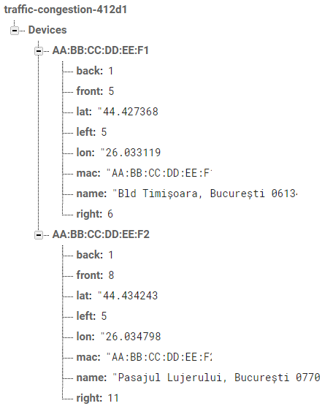

Fig 5.1 Data sended to the fire base

Now, if the traffic starts increasing at the road junction it will send its data to the firebase, traffic lights installed at that road junction will become red. All the traffic at that time stopped. The rotating camera counts the number of vehicles on that road junction and commands the traffic light, the side that has dense traffic open first and so on as shown in fig 5.2.

As the traffic on one side becomes normal on that side, traffic signals become red and the traffic on the other side starts moving as shown in fig 5.3.

Now if the traffic of all the sides become null at the late night time, the camera is only working and examines all the road side. If something uneven happens with the Smart traffic control and congestion tracker system the project will restart and work again properly.

If we consider the next case in which step by step vehicles are added to the traffic and congestion increases. Switching of the traffic lights are also shown in these steps and it will show us all the traffic movement of each side. We are using two cameras here and each is controlling four sides of the roads. Here right, left, front and back are the sides of the road junction from where the traffic came or goes. If any of the sides has no vehicle, then that side of the road is considered in the normal form. If that side of the road is not having dense traffic, then the excessive amount of traffic is considered as the terminated traffic. In such a case if any further addition of the traffic to that side of the road is considered as the excessive/over traffic and will be tried to switch on (green) the traffic light of that side. If all four sides of the road already have an excessive amount of traffic then the traffic light will turn green according to the density of the traffic on the sides of the road. This will be done by a controller which will give signals to all the four traffic lights on each side of the road. It has a few more systems in it, first of all the camera will inspect the traffic on each side of the road and send that data to the controller and also to the firebase. Firebase will notify all the gadgets that were attached with it. It is done by using the mobile app. The app receives the traffic report through firebase as shown in fig 5.4.

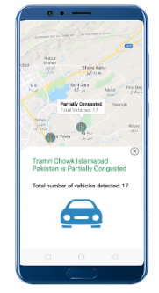

Fig 5.4.. Traffic congestion report of Tramri Chowk Islamabad, Pakistan on E-gadget

**5.2 Software (Mobile App)**

**5.2.1 Technology** Technology used for mobile app development is React-Native. Its cross platform mobile development technology developed by Facebook. It's actually an extension to React which is used for web development. React-Native’s first launch was in 2015. Nowadays React-Native is a famous Mobile Development Framework.   
The design language in React-Native is known as JSX (Javascript-XML) and the programming language used is JavaScript.

**5.2.2 Mobile App Investigation** After the Splash Screen, Google Maps view appears in the app. Using React-Native-Geolocation, mobile accesses the user location and animates the map view to the user's current location. The junctions where our Smart Device is installed will appear with a Marker on MapView. Fig 5.5 is the screenshot of the mobile app after splash screen.

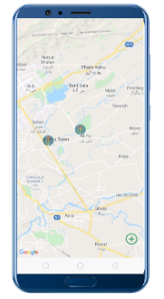

Fig 5.5. Smart Device Installed Junctions View in Mobile App

Once a user clicks on any of the markers (junction), the app will show the details of the congestion on that particular clicked junction. Fig 5.6 is the screenshot of the mobile app once the user has clicked any of the junctions.



Fig 5.6. Traffic Congestion Report at User’s selected Junction

**5.3 Working**

When we switch on the camera it will start investigating and count the vehicles on all the sides of the road junction and send all the data to the firebase. Firebase is a cloud with which all the electronic gadgets are connected. It generates a summarized report of the traffic vehicle of a certain place where cameras are installed for sensing and counting the vehicles. That summarized report is sended to the mobile or Electronic gadgets (E-gadgets) attached with the firebase or cloud network. By seeing that report the vehicles coming behind will take diversion if there is a traffic congestion on a certain road junction but if there is a normal traffic, vehicles will pass through that road junction. This firebase technique is a new idea that updates the data after a few seconds and precisely. In this technique it will perform action in four steps; first to take the picture of all sides of the road junction, second is to process the image and in which counting of vehicle is done, third is to update all the data globally because firebase data is updated on cloud and easily available anywhere in the world, fourth one is to update the traffic condition on the database.

**Chapter 6**

**Conclusion**

Basic idea behind the project is to decrease the traffic blockage in the urban areas so that the traffic congestion is reduced on the roads using smart and effective traffic control systems. It helps in the continuity of the traffic on jampack roads of the urban areas. Moreover it reduces the accidents on the roadside, blockage of roads, reducing congestion and the average waiting time (AWT) of vehicles. It provides a classification of different traffic management schemes used for avoiding congestion. Moreover, cameras are used for the counting of vehicles on the road and it sends its information to the cloud using a firebase. All the other traffic that is connected through the cloud has a clear information of the traffic on that specific location where the tracker is used, so they will deviate from that specific location and have a less chance of traffic congestion. It is an efficient way of traffic management, decreasing congestion and traffic accidents.

**6.1 Impact on Society**

Various types of traffic regulatory systems have been built in previous eras to decrease down the road accidents and lower down the congestion. For example, they can withstand bad weather conditions, night time, stormy weather and dense traffic clearly and effectively. Some of the features that have been designed into systems to enable them to withstand such normal events also offer protection against attacks of modest scale by terrorists.

**6.2 Impact on Environment**

* Smart traffic control and congestion tracker system is a fully automated project.
* Man power has been reduced.

This project can be implemented in any of the road junctions for reducing and managing the traffic of the urban cities.

**6.3 Future Work**

This project “Smart traffic control and congestion tracker system” focuses on real time implementation of traffic tracking and managing vehicles in congestion. If we must go further in future, then we have to use more better quality cameras for vehicle inspection and get more clear results.

One of the key difficulties in this project, it will operate the same for all the vehicles either someone is in an emergency situation or in normal mode. For example, if the ambulance came at that road junction it will also be stuck in that traffic, so the patient in that ambulance faces problems. To resolve these kinds of issues ambulances and other emergency vehicles have some other diversion so that they will face these kinds of issues.

**Acknowledgment**

The whole work is dedicated to our loving parents, respected and sympathetic teachers and caring class fellows who have supported us throughout our courses and final year project. There are a lot of other great persons who helped us and guided us in completion of our project, we are also thankful to those for standing with us in every situation. Shortly we are thankful to everyone due to those now our project is successful.

We wholeheartedly thank our project guide, Octavian Fratu, Professor of faculty of electronic and telecommunication department, for his constant support and encouragement throughout our project. We are grateful for his constructive advice during the final year project, which helped us make the necessary improvements.

We are also indebted to our parents that they encouraged us and keep supporting us for their valuable advice. They protected us from slings and arrows of everyday life and this made us able to complete our project and we are close to completing our BS Electronics Engineering degree for them at a well renowned university.

Name of Student

**Conflict of Interest**

Several attempts were made for the traffic optimization by researchers. But the challenge is to design a flexible model to deal with objectives like time, financial cost, convenience and environmental pollution etc. From the technical point of view, correct detection of vehicle density on road by keeping high accuracy including improved algorithmic solutions for multiple cues, for statistical and learning methods, sensors and telematics. One of the key aspects is proper collection of data and connecting the gadgets of the community with the cloud. Few of the other conflicts of the community is that if some of the emergency vehicles came at that road junction it will also be stuck in the large number of traffic. It will be risky for the life that is in that emergency vehicle.

**Bibliography**

1. Senthil Kumar Janahan1* , M.R.M. Veeramanickam2* , S. Arun3* , Kumar Narayanan4* , R. Anandan5* , Shaik Javed Parvez International Journal of Engineering & Technology, 7 (2.21) (2018) 309-312 https://www.dsowardha.com/dsowr/public/pdf/IoT_based_smart_traffic_signal_monitoring_system_u.pdf
2. [Elizabeth Basil](https://ieeexplore.ieee.org/author/37086399344) and [S.D. Sawant](https://ieeexplore.ieee.org/author/37086305097), Department of Electronics and Telecommunication NBNSSCOE, Pune, India, [2017 International Conference on Energy, Communication, Data Analytics and Soft Computing (ICECDS)](https://ieeexplore.ieee.org/xpl/conhome/8379907/proceeding)

<https://ieeexplore.ieee.org/abstract/document/8389604>

1. Ninad Lanke1* and Sheetal Koul2*[International Journal of Computer Applications](https://www.researchgate.net/journal/0975-8887_International_Journal_of_Computer_Applications) 75(7):19-22 · August 2013 <https://www.researchgate.net/publication/260833477_Smart_Traffic_Management_System>
2. Raspberry pi <https://www.electronicwings.com/raspberry-pi/raspberry-pi-introduction>
3. PiCamera <https://www.electronicwings.com/raspberry-pi/pi-camera-module-interface-with-raspberry-pi-using-python>

ANNEXURE

Software code for